THE UNCOVEROR
Revealing the things they don’t want you to know. It’s the real news!

ISSUE 1

WE ARE BACK ... FOR NOW, AT LEAST
For the first time in several years, THE UNCOVEROR is once again a printed newsletter. People who don't have access to computers can't read our website, www.uncoveror.com, but have a right to know the real news.

As some of you may have read on the website, they made it impossible to continue our printed newsletter, so the net has been our only medium. No one can tell where a website comes from, but if they find out where this came from, we'll have to stop printing again, so read this while you can.

We promise that our website will never go away, so get access to a computer with an internet connection! It is good to be back in print.

NASA TO EMPLOY MEDIEVAL TECHNOLOGY IN COST-CUTTING MOVE
In a move some call genius and many call ridiculous, NASA will soon combine the middle ages with the space age. Budget cuts have heavily curtailed the agency's satellite deployment plans, so NASA has decided to develop a new launch vehicle: a giant catapult that will literally fling satellites into orbit.
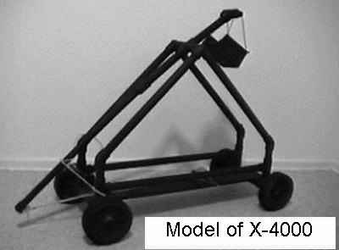
"The X-4000 Launch Apparatus will be the largest working machine ever constructed by man," says NASA spokesman, Dr. Ivan Ivanovich. "It will save us millions to not have to use rockets or the Space Shuttle. The only expensive consumable will be the high tech micropolymer ropes needed to pull back the launching arm, and create tension. They will cost several million each, and can only be used once, but are much cheaper than a rocket or shuttle launch."

The specifications for the device call for a frame made of a space age titanium alloy, and a
throwing arm made of a highly flexible, yet nearly unbreakable carbon fiber compound. The ropes Dr. Ivanovich mentioned will be pulled taut by a powerful hydraulic winch, and then cut with a synthetic diamond blade, the only substance capable of cutting these ropes. A huge hydraulic pile driver will force the blade down onto the rope at nearly the speed of sound, then off the payload goes into orbit, or so it says on the drawing board.

Former NASA employee, and frequent contributor to THE UNCOVEROR, Harvey Kurtz had a lot to say on the subject of the X-4000. "It's a boondoggle, and a potential disaster. If the trajectory or tension are just a little off, then the X-4000 could slam it's payload onto land with the force of the bomb dropped on Nagasaki! Satellites are launched in many directions to achieve various types of orbit. Cuba, Hispaniola, Puerto Rico, Texas, Mexico, and many other populated areas could be hit by a misfired launch, and what if they hit an airplane? Oh the humanity!"

He also informed me that plans like this are not new. "In the eighties, the Air Force planned what was basically a giant crossbow to launch disk-shaped payload vehicles carrying satellites. They even considered it as a way to launch the shuttle. A working prototype was built at Area 51, and test launches were responsible for countless UFO sightings. Also, nothing ever got into useful orbit. Some payloads re-entered the atmosphere and burned up. Some landed in the ocean, and some just kept going deep into space." Mr. Kurtz pointed out that the whole thing was based on seized Soviet plans; plans that many felt must be part of an elaborate Kremlin campaign of disinformation and phony intelligence. "To make matters worse, the first bowstring supplier had defrauded the Air Force. The high tech micropolymer ropes they were selling were actually ordinary ones dyed blue! Until they discovered this, the apparatus did not work at all, the ropes would break every time. Even the real ones they finally got only worked once, then were to weak to use again.

Mr. Kurtz urges all Americans, "Write NASA, E-mail and phone them, as well as your Congressmen and Senators. Urge them to stop this ludicrous program before it turns tragic! A source of mine tells me they have already broken ground on the construction site."

Remember, you read it here first.

DIET FOOD MAKING AMERICANS FAT
It has come to the attention of THE UNCOVEROR that "lite," "diet," "low fat," "low calorie," and other such foods and beverages are making us fat.

They contain a powerful drug to block the hormonal signal that tells the brain that we are full, so we will gorge. They also contain another substance to make us feel lethargic, discouraging exercise.

Why? The diet and weight loss industry is big business, raking in billions each year. A vast conspiracy is afoot to shake us down for even more. It's goal: making us overeat, not exercise enough, and feel bad about it so we will use their products.
Television, magazine, and billboard advertising are part of the conspiracy. Skin-and-bone thin models are shown in sexually provocative poses and clothing, looking happy. They make Americans see their bodies as too fat. We Get the idea that if we looked like these models, we too could be happy, and attractive. Subliminal messages are even used to drive the point home. These methods lure us into to the conspiracy's web of profiteering.

Doctor Simon Hurtz, who used to be a part of the conspiracy, until his daughter became anorexic says, "First, people see the ads, then they buy the doped up foods and beverages, then the drugs kick in." Dr. Hurtz advises us to eat the foods and drink the beverages that are supposed to be bad for us, not "diet" foods. They are unlikely to contain the drugs.

EL CHUPACABRA BREEDS WITH DOG IN CALIFORNIA
The infamous goat-sucker is up to new tricks, according to El Cajon, California rancher, Joseph Ramirez.

Instead of just killing his livestock, and drinking their blood as it usually does, the monster bred with his dog!


“I had waited all year for my prized golden retriever, Fluffy to go into heat so I could breed her. A good friend of mine has a male named Fetch who has won dog shows. He and Fluffy had made beautiful puppies together before,
which had sold for hundreds of dollars each.

I wanted them to do it again. Instead, I have these mutt-ugly el chupacabra pups! I’ll have to offer them free to a good home to have any chance to unload them.”

Ramirez reports that a farmhand of his heard poor fluffy yelping, and ran to help her, only to find El Chupacabra doing the dirty deed to her.
"He was so shocked that he dropped his bottle of tequila! He didn’t tell me what had happened for two days.” "What really tees me off," exclaimed Ramirez, "is that I already paid the stud fee for Fetch to breed her, not knowing she had already been nailed."

Ramirez reports that the puppies have tried to attack goats on neighboring farms.
Cryptozoologist John Sheist, of Brandine University says “This lends credence to the theory that El Chupacabra is a kind of canine. After all, It kills goats, sheep and cattle, drinking their blood. It doesn’t try to breed with them.” Many are skeptical that this could be true.

James Brewster, a student, and fraternity member at Brandine says, “I don’t care what some drunk farmer in El Kabong California says. There is no such thing as El Chupacabra. This guy just got some ugly pups. If they have attacked goats, that is because some dogs are just mean!”

Anyway, Joseph Ramirez has nine of what he calls el chupacabra pups available free to a good home in El Cajon, California.

AIR FORCE SECRETLY ADMITS UFOS EXIST, HAS PICTURES

THE UNCOVEROR has recently obtained an e-mail from an Air Force General to an Air Force Colonel about a UFO sighting. We even have the photograph they discuss! It was dangerous for our sources to get this information, but here it is.
Date: XXXXXXXXXXXXXX 13:56PM PDT
From: XXXXXXXXXXXXXXXXXXXXX
To: XXXXXXXXXXXXXXXXXXX
Subject: Thoroughly analyzed this one. I don't think it's a hoax Colonel. I believe we are dealing with some ...
More Details
--------------------------------------------------------------------------------
Thoroughly analyzed this one. I don't think it's a hoax Colonel. I believe we are dealing with some very advanced technology. Notice the thrust distortion below the object (spacecraft?).

I honestly believe this one is a valid case of extra-terrestrial evidence. I would recommend a thorough "debriefing" of all parties involved and that every copy of this photograph be acquired or destroyed. I don't think I need to stress the importance of this matter. Utmost secrecy
must be maintained at all costs.
Regards,
General Alfred W. Mercer III

UFOs are real. and the government knows it. Here are some other photos that have been obtained by our sources. We had them scrutinized by Dr. Marcus Von Vickersburg, from The International Institute for Photographic Analysis.

"It should be noted," remarked Dr. Von Vickersburg, "that digital photographs can not be faked, And these are digital photographs. I find their existence very disturbing!
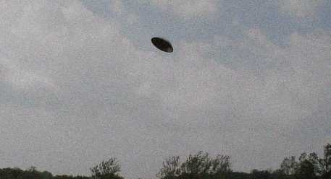
This is no hoax!"

FLESH EATING TERMITES ATTACK CAMPERS AT RED RIVER GORGE

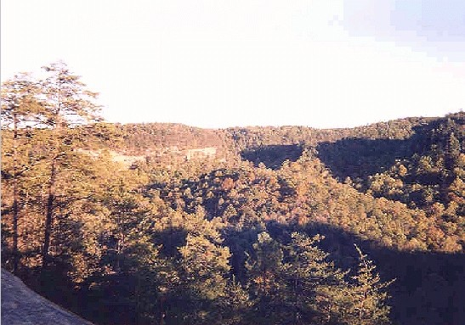
A new strain of termites, not the normal wood eating variety, but flesh eating termites, has been discovered at Red River Gorge.
Dry Ridge Kentucky native, James "DogStar" Rattley found this out in very painful fashion when they invaded his campsite.

"Some dude told me when I was setting up my tent that I had better move. There was an old dead tree right by there, and he told me there would be bugs. I laughed him off. It's the great outdoors, so of course there will be some bugs, man, but then those termites showed up in about five minutes. They didn't touch the firewood, but they jumped me and my pal Moonie and started biting. They broke the skin, and drew blood! We ran, but Moonie tripped on a tree limb that fell, and they swarmed on him!
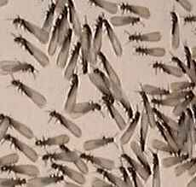
Bertram "Moonie" Smith was completely devoured by the ravenous swarm of insects. Nothing but bones remained behind. How widespread this new variety of termite has gotten is not yet known, but their point of origin seems to be near Red River Gorge. Dr. Thomas Natchez of The Center for the Institute of Studies had this to say about the phenomenon. "Years of unregulated chemical dumping probably mutated the genes of the termites. That alone did not create this problem. New Dawn Biotech built a series of greenhouses here as a proving ground for a genetically engineered meat that grows on trees. (See page 6 for that story) They had the best of intentions: Producing meat without cruelty to animals, but when some of the trees died, they attracted these termites, and they discovered that they like flesh and blood better than wood!"

New Dawn Biotech's entire plantation was soon gone, and the company went to a great effort to cover it up, but Dr. Natchez found out, and contacted THE UNCOVEROR. We thought something was bound to go wrong with Treemeat, and now it has!

Several insecticide experts, Including representatives from the five largest commercial exterminators in the world have been called in to deal with these new termites. They are immune to all insecticides that have been tested so far, and are not attracted to conventional termite baits. "This may be the worst insect related disaster since Africanized or 'Killer' bees!" says Dr. Jorge Ramirez, Chemical engineer at Brandine University. "If we can't find a solution soon, I don't know what can save this popular tourist area, and they may have already spread!"

We will keep you posted as this story develops. Once again, a cover up has been thwarted by THE UNCOVEROR. You found out the easy way, unlike DogStar and Moonie.

GOOD NEWS FOR VEGETARIANS: MEAT THAT GROWS ON TREES

There is good news for vegetarians. New Dawn Biotech of Alberta, Canada has genetically engineered meat that grows on trees. Soon, no more cute or furry little animals may have be slaughtered for meat. Animal rights activists can rejoice. So far, they can grow slabs of ribs, sirloin steaks, and venison in a purely vegetative manner. The gene splicers are working on more, such as pork chops, ham, t-bone steaks, filet minion, and hamburgers.

"It's not ready for market yet." Says Dr. Norman Taurus of New Dawn Biotech's foods division. "The first two versions, Treemeat 1.0 and Treemeat 1.1 were both foul tasting, and potentially carcinogenic." "Treemeat 1.2 was much sweeter tasting, and higher in saturated fat than animal derived red meats. It also had a certain fakeness to it's taste, but soon we will have vegetative meat that looks, tastes and smells like the original." Dr. Taurus also began to tell me that the engineering of Treemeat is coming along quicker than the Chick'N project, but a man in a suit then came and whispered in his ear, and he would say no more about the Chick'N project. He even claimed that he was making a joke, and that there was no such thing. We suspect that there is more to it than that. (for more information on the Chick'N project see the article, IS IT CHICKEN AT ALL?)

After telling me about the Treemeat, he then took me to a greenhouse where they had it growing. I saw it with my own eyes! Thick juicy steaks, and slabs of ribs hanging from the limbs. It appeared to be moist with actual blood. It even dripped a little. Dr. Taurus told me that as long as it stayed on the vine, it would stay fresh, needing no salting or refrigeration. Once it is picked however, It can spoil, and must be treated just like animal derived meats. At the end of the tour I was offered a sample of Treemeat 1.3. It tasted pretty convincingly like a steak, but left a maple syrup like aftertaste. Though many people may like the idea of having meat without "killing Bambi'" so to speak. I can't help wonder whether something will go terribly wrong. We will keep you posted.

I was not allowed to take any photographs, but I have people who might just be able to get me some. Check our website, www.uncoveror.com from time to time to look for them.

IS IT CHICKEN AT ALL?

It has come to the attention of THE UNCOVEROR that a letter is circulating the internet, accusing the former Kentucky Fried Chicken of shortening it's name to KFC, because it no longer serves chicken. The letter accuses KFC of using meat from a genetically engineered mutant bird-like creature. We decided that we needed to investigate. Here is a copy of that letter.

Unless somebody can prove otherwise, this is pretty interesting.........
KFC has been a part of our American traditions for many years. Many People, day in and day out, eat at KFC religiously. Do they really know what they are eating? During a recent study of KFC done at the University of New Hampshire, they found some very upsetting facts. First of all, has anybody noticed that just recently, the company has changed their name? Kentucky Fried Chicken has become KFC. Does anybody know why? We thought the real reason was because of the "FRIED" food issue. It's not. The reason why they call it KFC is because they can not use the word chicken anymore. Why? KFC does not use real chickens. They actually use genetically manipulated organisms. These so called "chickens" are kept alive by tubes inserted into their bodies to pump blood and nutrients throughout their structure. They have no beaks, no feathers, and no feet. Their bone structure is dramatically shrunk to get more meat out of them. This is great for KFC because they do not have to pay so much for their production costs. There is no more plucking of the feathers or the removal of the beaks and feet. The government has told them to change all of their menus, so they do not say chicken anywhere. If you look closely you will notice this. Listen to their commercials, I guarantee you will not see or hear the word chicken. I find this matter to be very disturbing. I hope people will start to realize this and let other people know. Please forward this message to as many people as you can. Together we make KFC start using real chicken again.
No wonder their pieces are so small.......

THE UNCOVEROR contacted KFC's national Headquarters, who issued a total denial.
No one at University of New Hampshire could be reached for comment. We decided that we needed to investigate this in depth ourselves.
After some digging, we found a KFC employee who provided us with samples of the chicken used in sandwiches and tenders. Upon request, we are not publishing his name.
We took these samples to Brandine University to be tested. As the letter states, the meat was not chicken. The animal in question had some chicken genes, but obvious signs of gene splicing were detected.

Some of the genetic material seemed to be from ostrich, and some even from turtle, or possibly snake.

After considering the letter, the genetic findings, and conferring with his colleagues, Dr. Richard Payne concluded that chicken-like creatures could indeed exist.

He also told us that probably only one company, New Dawn Biotech, was capable of creating such a thing. We contacted their labs in Alberta, Canada. Like KFC, New Dawn Biotech denied that they were involved in any such thing.
THE UNCOVEROR will continue to dig on this one, and will update this story if we find out any more.
By the way, KFC has always been pressure cooked, or baked. It was never fried.
If what the letter says is true, then KFC is NOT FROM KENTUCKY, NOT FRIED, AND MOST IMPORTANTLY, NOT CHICKEN.

BAD NEWS FOR VEGETARIANS: PLANTS FEEL PAIN

It has come to our attention at THE UNCOVEROR that something startling has been discovered by Dr. Bill Williams, a botanist at The Helvetica Institute. If his preliminary findings turn out to be true, they will prove that killing plants for food is no less cruel than killing animals for food. "Plants are aware," says Dr. Williams, "and they feel pain!"

Dr. Williams, and his team were doing experiments on talking to plants. He had set out to prove that this helped them only because it blows carbon dioxide over their leaves. He had one team speak lovingly to the plants, and another threaten and verbally abuse them. To the surprise of all involved, the plants that were lovingly spoken to thrived, producing large, lovely flowers. Their growth rates were off the charts! The plants that were verbally abused and
threatened never bloomed. Some even withered and died.

His team then connected EEG electrodes to several plants, and measured their responses to various stimuli. "They definitely felt it when we pricked them with needles. One of my staff even burned one with a lighter. Not only did it's EEG go off the charts, but so did every plant in the same room!"

Dr. Williams is submitting his findings to other scientists for further review. He told me that plants not only seem to be aware and to feel pain, it looks like they can even communicate. They may even be sentient beings. He told me, "I hadn't thought of it until now, but how does a fruit tree know how to make a sweet attractive fruit that animals will eat when it drops off, and spread the seeds? How do flowers know how to attract bees with sweet, fragrant nectar, and get their pollen spread about, assuring a next generation? They may be doing this consciously!"

Maybe Disney, or some other animation outfit will make a cartoon about a happy little vegetable. Maybe he'll be called Buddy the Carrot. He'll lose his mother to the farmer when he picks her, and eats her. That could do to vegetables what Bambi did to meat! Carrots may in fact be more intelligent than deer. Who knows for sure? You read it here first at THE UNCOVEROR.

ALIENS INVENTED UNIX

An unnamed source from Nellis Air Force Base in Groom Lake Nevada, commonly known as Area 51,
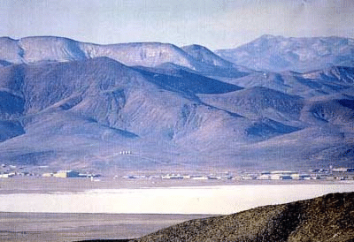
has revealed to THE UNCOVEROR that the Unix computer operating system is alien technology.

Unix was reverse engineered from the computers on the Roswell UFO. "Nothing that close to perfect has ever been developed by human beings," said the Area 51 employee. The government did not want you to know this. AT&T, who claim to have invented Unix, did not want you to know this. Now, thanks to THE UNCOVEROR, you do.

TOILET BOWL SNAKE ATTACKS ON THE RISE



More now than ever, people who sit down on the commode just to relieve themselves are being bitten in their posteriors by venomous snakes.
The culprits include water moccasins and copperheads.
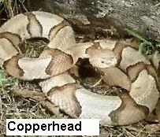
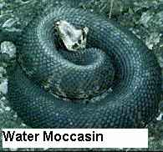

The Federal Bureau of Statistics reports that in 1997, there were 105 reported toilet bowl snake attacks, resulting in 17 fatalities. In 1998, there were 135 attacks and 30 fatalities. In 1999, 200 attacks were reported, and 50 fatalities. Why?

According to Harvey Schitz at the Federal Bureau of Statistics, urban sprawl is to blame. "We keep building new subdivisions way out in areas that used to be wilderness, and have disturbed natural reptile habitats. This was bound to happen." Mr. Schitz added that people who live in the city are much less likely to be attacked in this manner.
"Until new serpent-proof toilets and plumbing are developed, This problem is going to get worse and worse out in the suburbs. Maybe it isn't so dangerous back in the city after all!"

The Uncoveror is published at irregular intervals from a location that must remain undisclosed. Subscriptions to the printed newsletter are not available, so when you see a copy, grab it. Our website, WWW.UNCOVEROR.COM and it’s Mirror site WWW.UNCOVERER.COM are always free, and we encourage you to print the pages from our websites, and give them to people without computers. “The Uncoveror”, “Revealing the things they don’t want you to know”, “the real news”, and “It’s the real news.” Are trademarks of THE UNCOVEROR. All Rights Reserved.
The Uncoveror, in both its print and online forms, is intended only for the entertainment of the reader.

